Project 4 Report

|  |  |  |  |  |  |
| --- | --- | --- | --- | --- | --- |
| Sorting Technique | Average time for 1000 random numbers times | Average time for 10000 random numbers | Average time for 100000 random numbers , | Average swaps | Average comparisons |
| Bubble sort | 0.003155 | 0.309444 | 35.453 | 249963 - (1000 numbers) | 498651 -(1000 numbers) |
| Insertion sort | 0.0011827 | 0.0952558 | 7.57347 | 999 - (1000 numbers)  10998 - (10000 numbers)  110997 - (100000 numbers) | 251358 - (1000 numbers)  2.52928e +07 (10000 numbers)  2.52433e + 09  (100000 numbers) |
| Selection sort | 0.0019683 | 0.138624 | 13.1984 | 499500 - (1000 numbers)  109980 - (10000 numbers)  1.10997e+06 - (100000 numbers) | 251358 - (1000 numbers)  5.04945e+08 -(10000 numbers)  5.05044e+10 -  (100000 numbers) |
| Merge sort | 0.0002533 | 0.0021085 | 0.0238082 | 2263.3 - (1000 numbers)  25414.9 - (10000 numbers)  257924 - (100000 numbers) | 11709.7 - ( 1000 numbers)  162171 - (10000 numbers)  1.99859e+06 ( 100000 numbers) |
| Quicksort | 0.000162 | 0.0017463 | 0.0165077 | 2758 - (1000 numbers)  38072 - (10000 numbers)  468464 - (100000 numbers) | 7864- ( 1000 numbers)  117307 - (10000 numbers)  1543764 - (100000 numbers) |

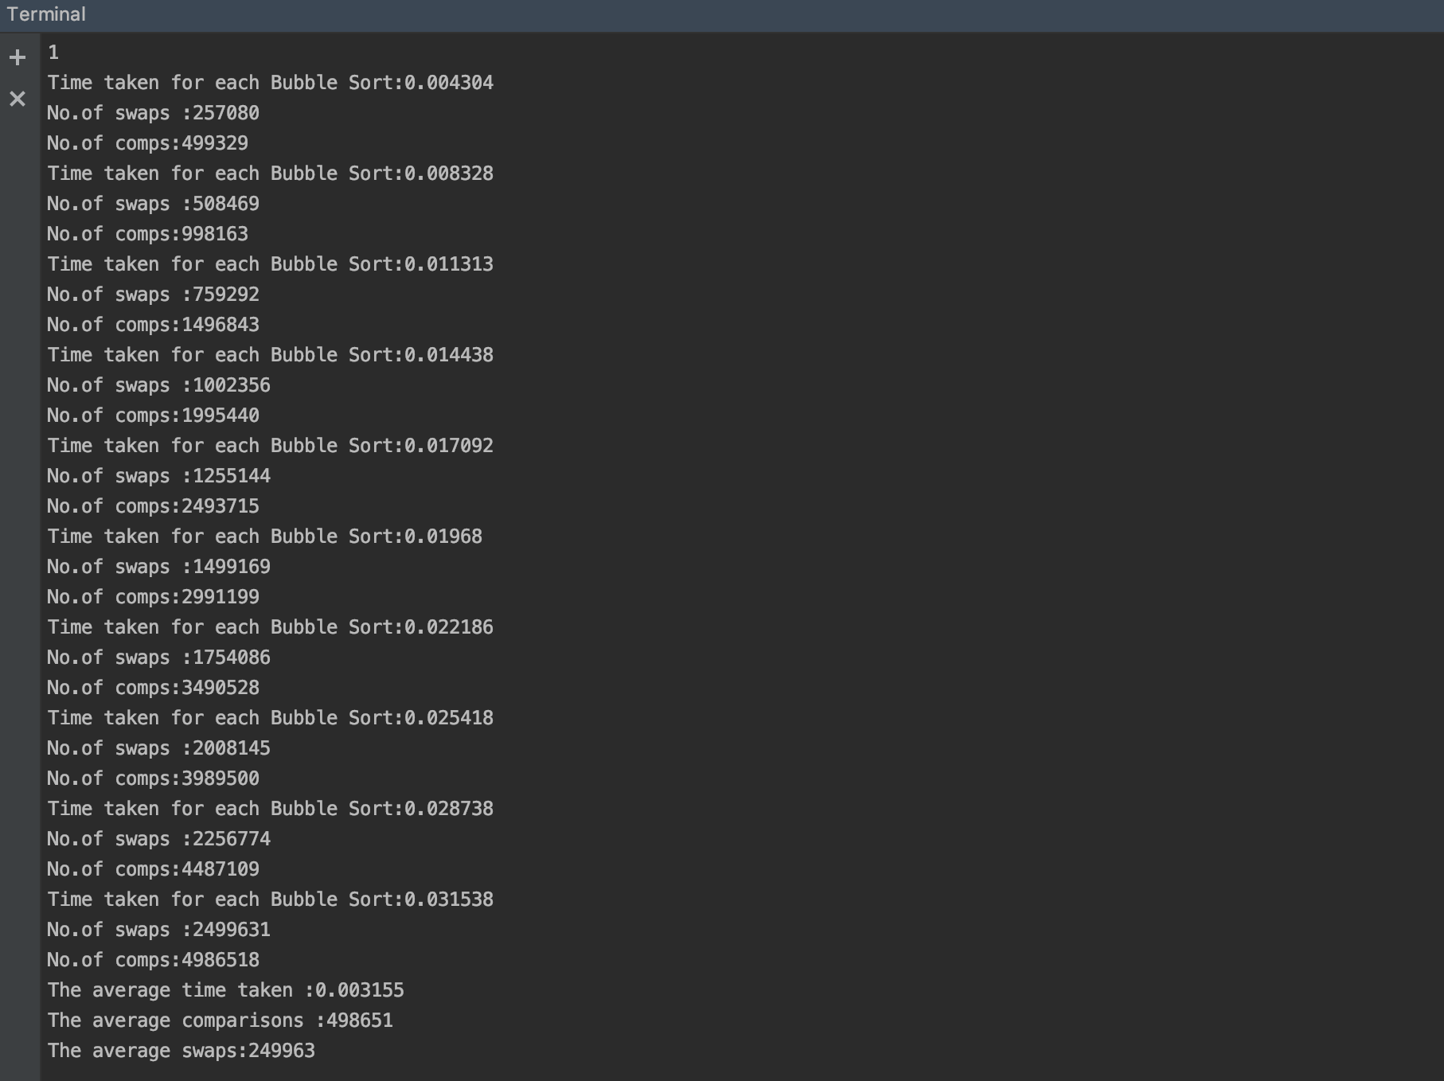

Bubble Sort for 1000 randomly generated items

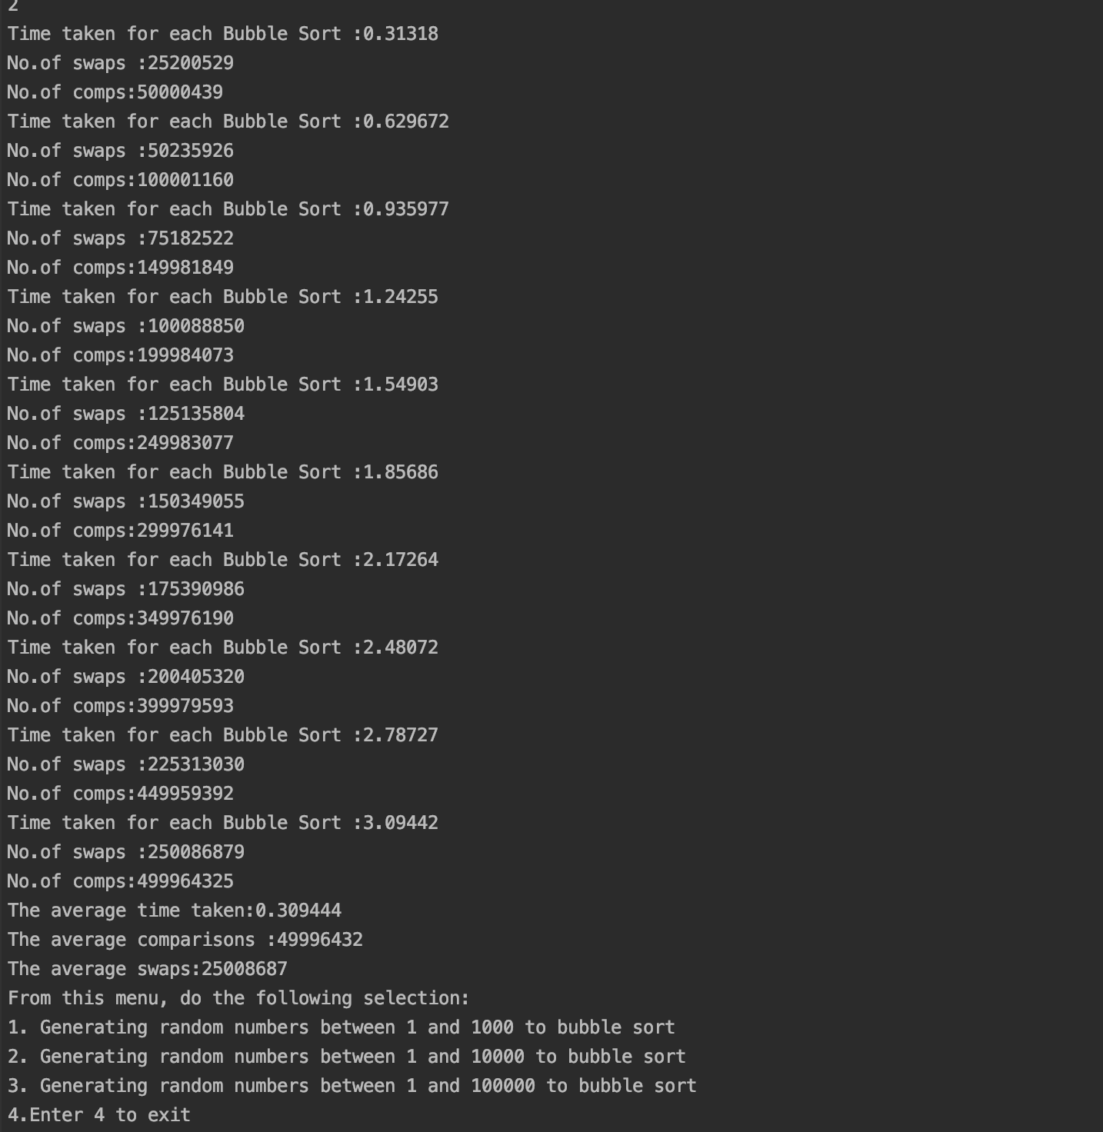

Bubble sort for 10000 randomly generated numbers

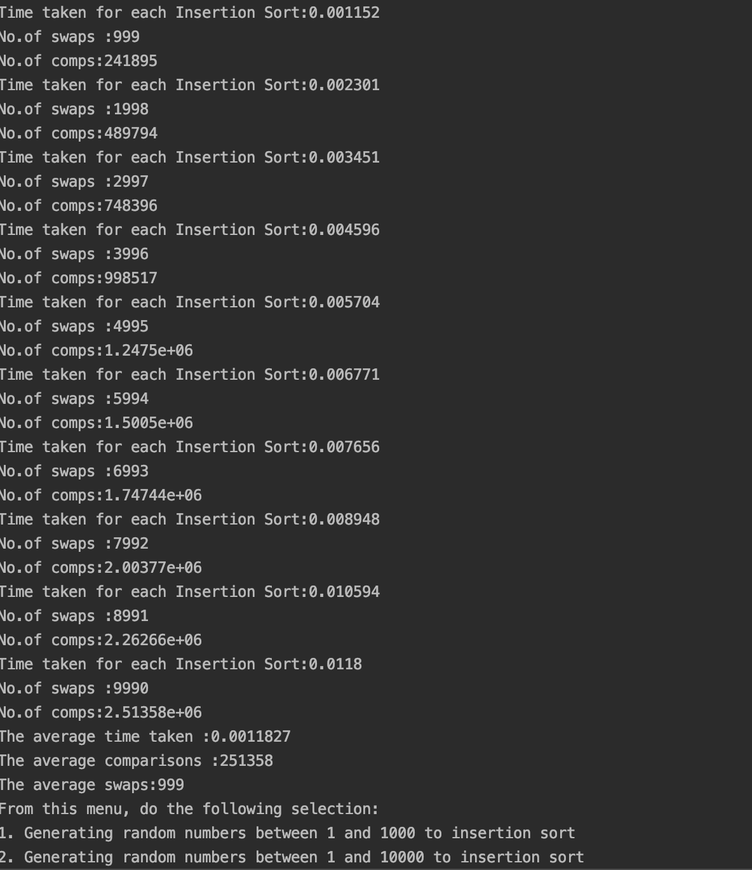

Insertion sort for 1000 randomly generated numbers

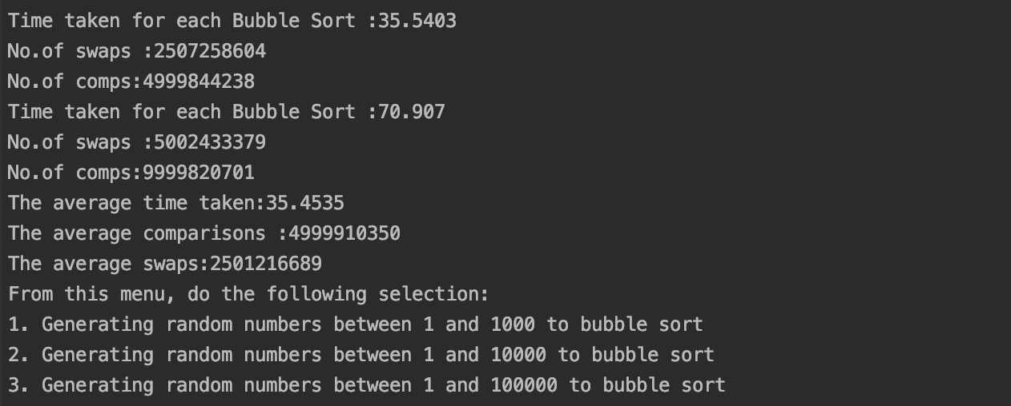

Bubble sort for 100000 random numbers

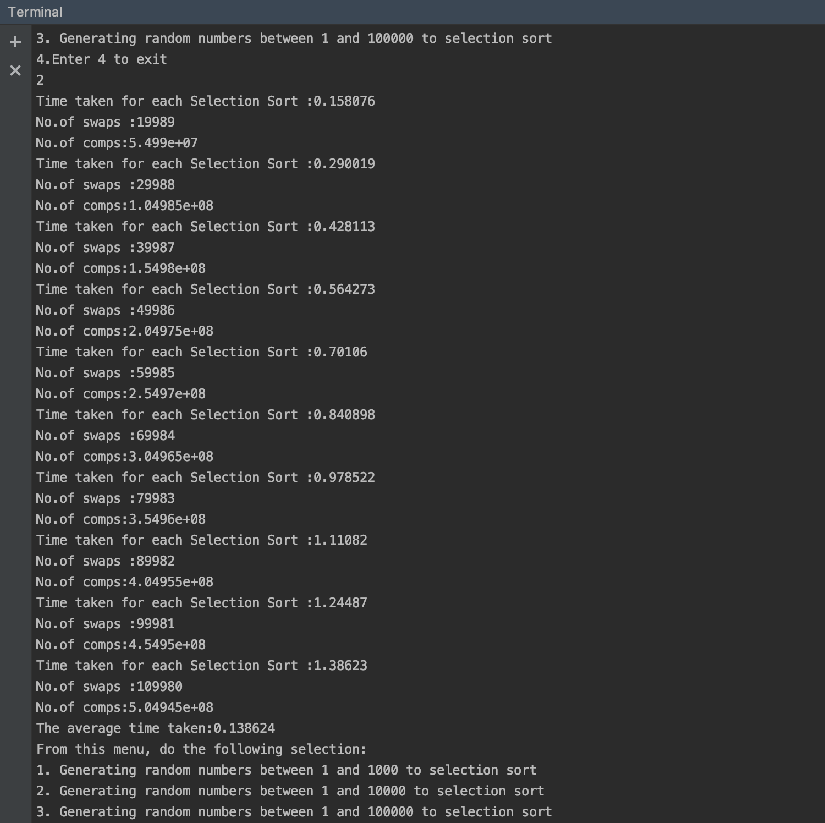

Selection sort for 10000 numbers

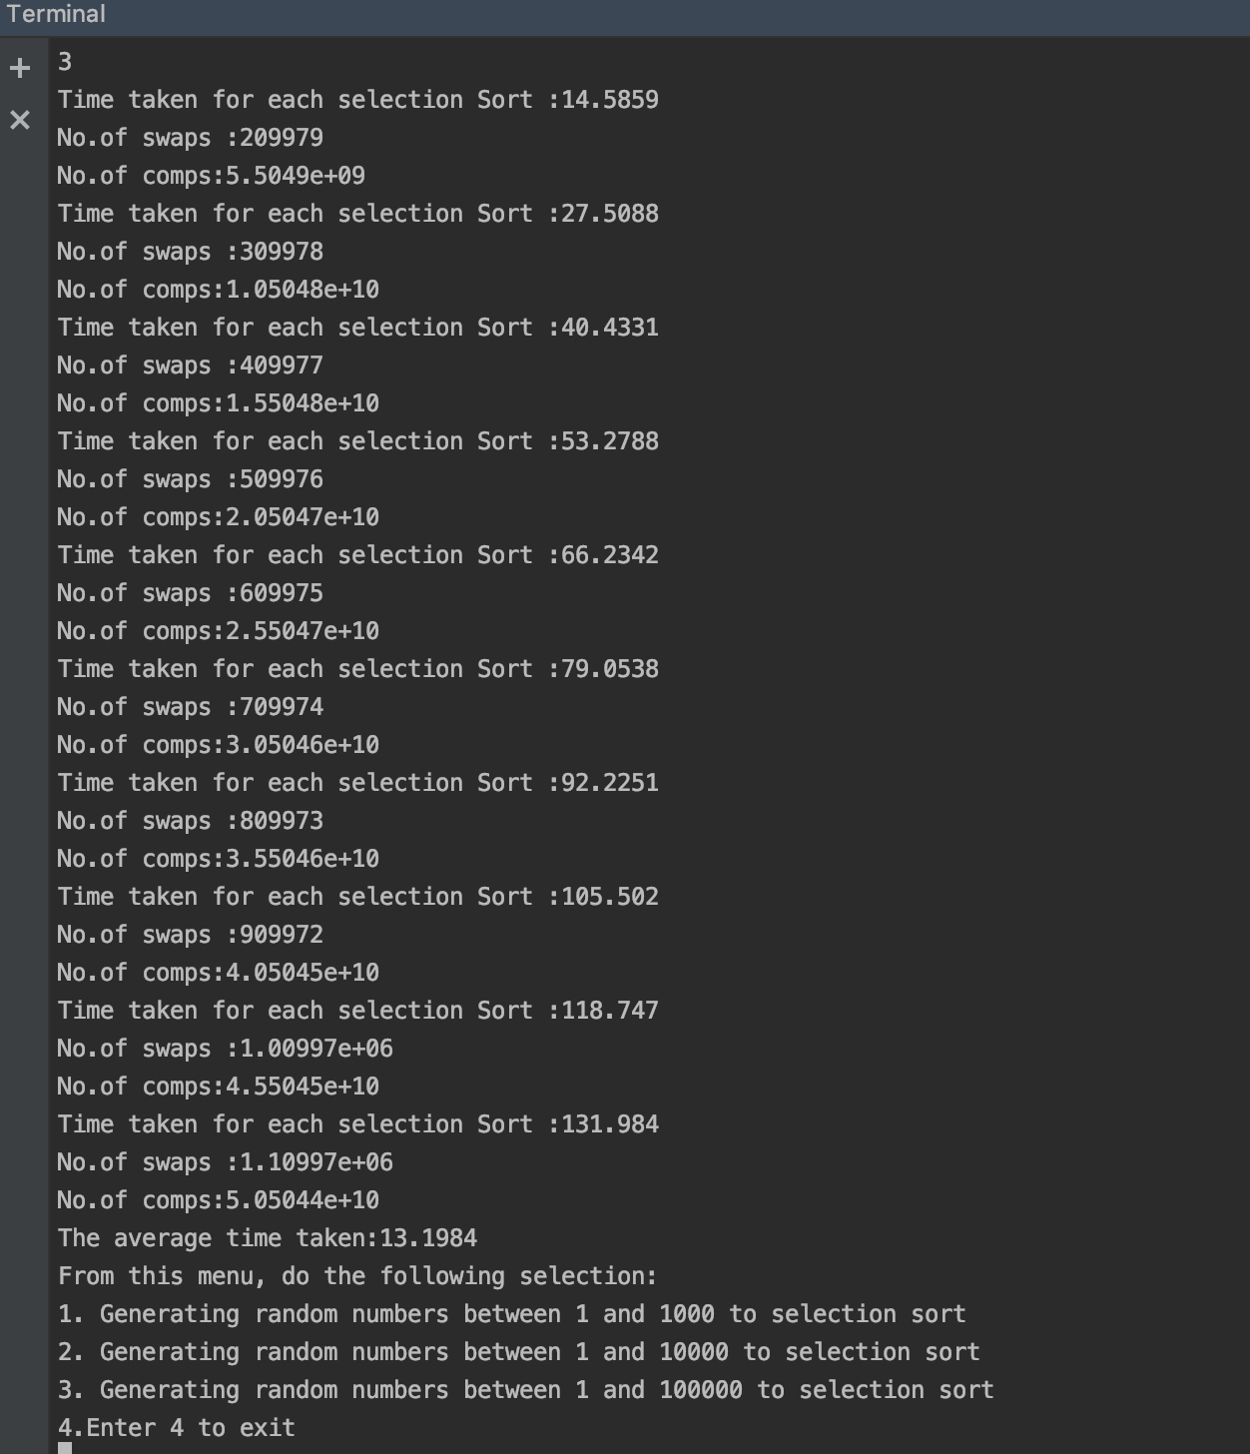

Selection sort for 100000 numbers

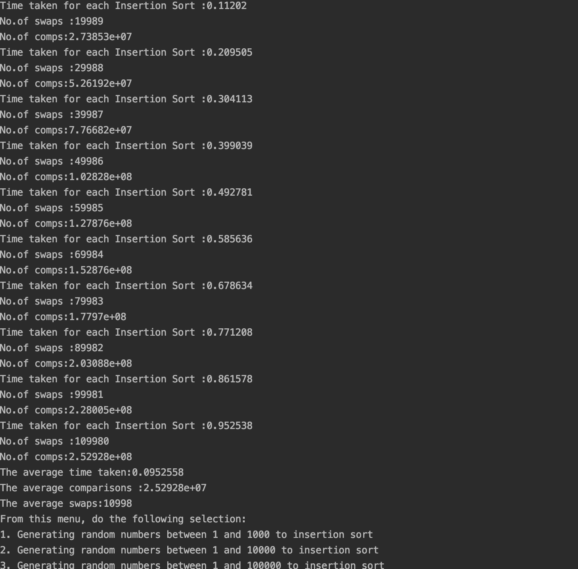

Insertion sort for 10000 randomly generated numbers

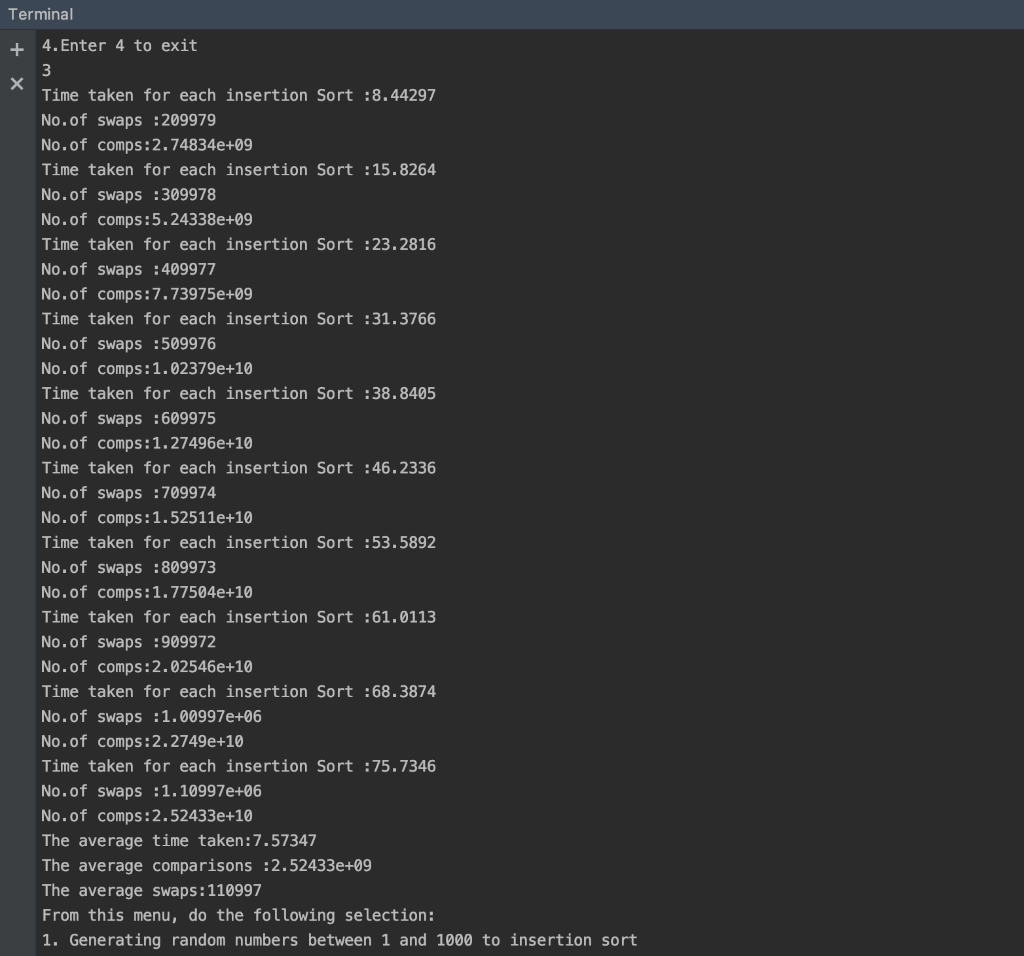

Insertion sort for 100000 randomly generated numbers

